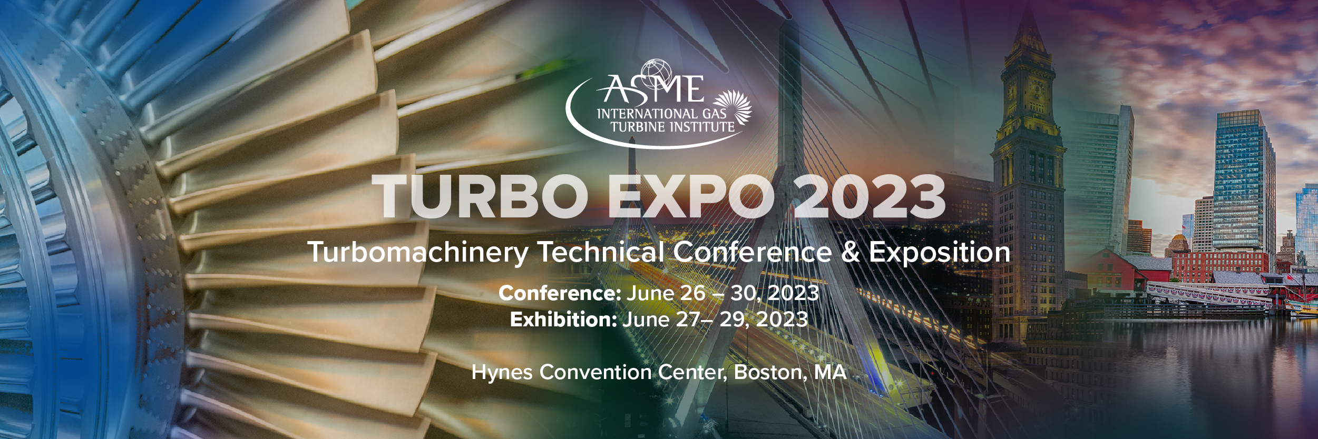

Facility Tour Pre-Screening Application

Brayton Energy, LLC. is hosting a tour 2023 ASME Turbo Expo delegates at their facility in Hampton, NH on Tuesday, June 27, 2023. A complimentary van will depart from the Sheraton Hotel at 7:45am and will arrive at Brayton Energy at 8:45am. The tour will be from 9:00 to 10:30am and is restricted to 25 participants. Guests will be driven back to the Sheraton Hotel and can expect to arrive by 12:00pm. *
Tour description:
Brayton Energy is an engineering company specializing in the design of turbomachinery, combustion, energy storage systems, and compact high-temperature heat exchangers including recuperators for microturbines and gas turbines. The facility houses many novel engine systems and specialized test rigs; examples include a 350 kWe intercooled recuperated gas turbine with ceramic hot section, counter-rotating axial turbomachinery for reversing Brayton cycle energy storage, and a concentrating solar power test facility with particle thermal storage. Project areas include gas turbines for alternative energy sources such as solar, biomass, nuclear and space power. The staff is nominally 50 engineers, technicians, and designers operating from a 4-acre campus in Hampton NH, providing engineering, design, fabrication, and test services.

Inquiries regarding this tour may be directed to: Jim Kesseli (kesseli@braytonenergy.com). Each delegate wishing to take the tour must complete the information below and return it no later than June 22, 2023.

Please print:

First Name:
Last Name:
Job Title:
Company Name:
Address:
Telephone: |  |  |  |  |  |  | Email
Date of Birth: |  |  |  |  |  |  |  | Passport #:
Date & Country of Issue:
Period of Stay (dates):

Submit to:
Brayton Energy, LLC.
Attn: Jim Kesseli
Email: kesseli@braytonenergy.com
Phone: +1 (603) 601-0450

*All tours are conducted at the discretion of the host company and under the conditions the company establishes. All tours are subject to cancellation.

