

FINAL PROGRAM/EXHIBIT DIRECTORY
The online directory includes an alphabetical list of exhibitors with a brief company description, a floor plan and a product category directory.

A standard directory listing will include a 40-word description. For a nominal fee, you can increase your listing up to 100 words and a logo. Please see the Advance and Final Program Advertising Insertion Order Form for pricing and ordering information.

PROGRAM ADVERTISING
Affordable advertising opportunities are available in the official Advance and Final Programs. For pricing details visit the Turbo Expo Ad Insertion Order Form.

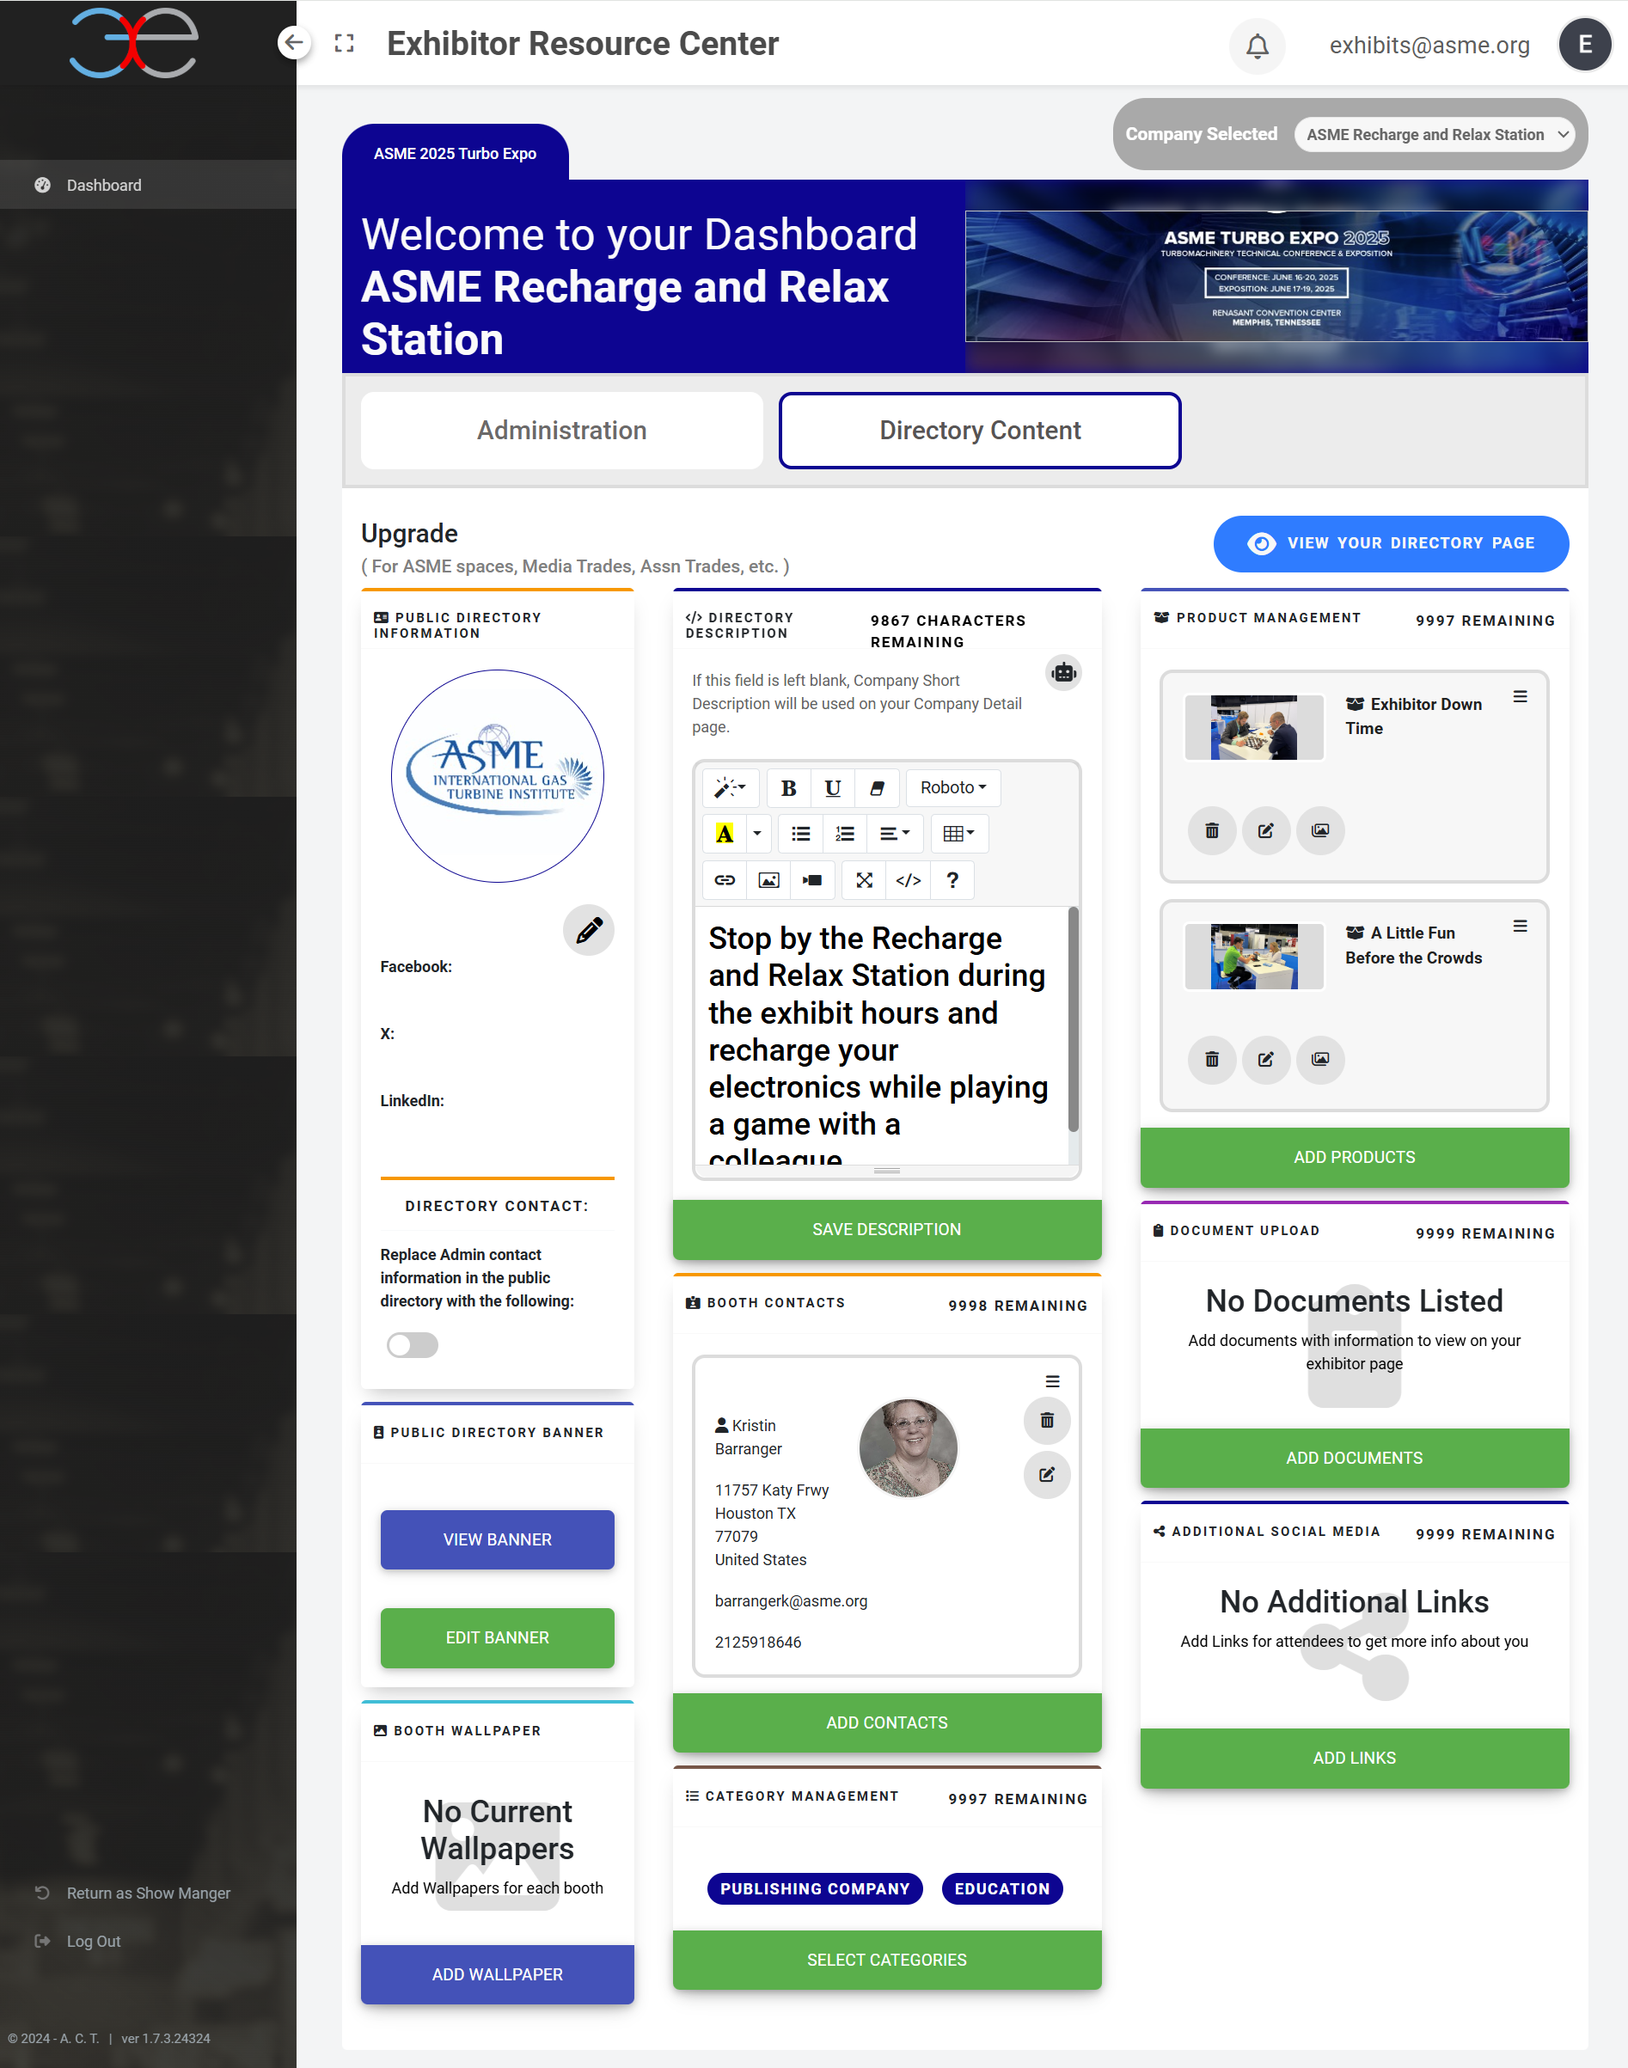
ONLINE EXHIBITOR DIRECTORY AND PRODUCT LOCATOR
**Exposure Beyond the Exhibit Hall**
Every Exhibiting Company will be responsible for accessing and updating their company listing. The information in the Online Exhibitor Directory will be used for the creation of the online Exhibitor Directory for the App for attendees to search for exhibitors by product category prior to and during the Show for planning their floor visits. To be included in the Final Program, your online listing must be updated by March 15, 2025. Please contact ASME if you need access to the site.

Your online listing enhances your visibility before, during and after Turbo Expo. Take control of your exhibit and customize your online booth information. Add press releases announcing any new products or services or activities within your booth. Showcase your products and services or add a video and be sure to include your social media outlets. This is all INCLUDED with your booth purchase.

What attendees see: https://asme.expocad.com/Events/te25/index.html. When they click on your booth – this is an example of what they see.

